ASSIGNMENT NO 7

Q1 ANSWER

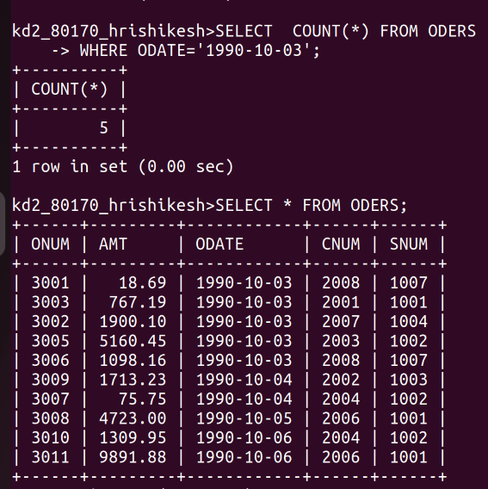
K

Q2 ANSWER
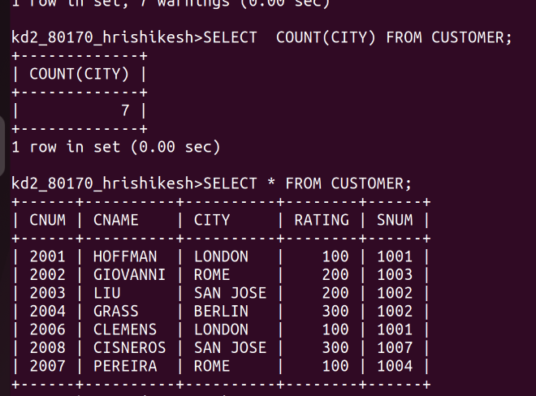
K

Q3 ANSWER

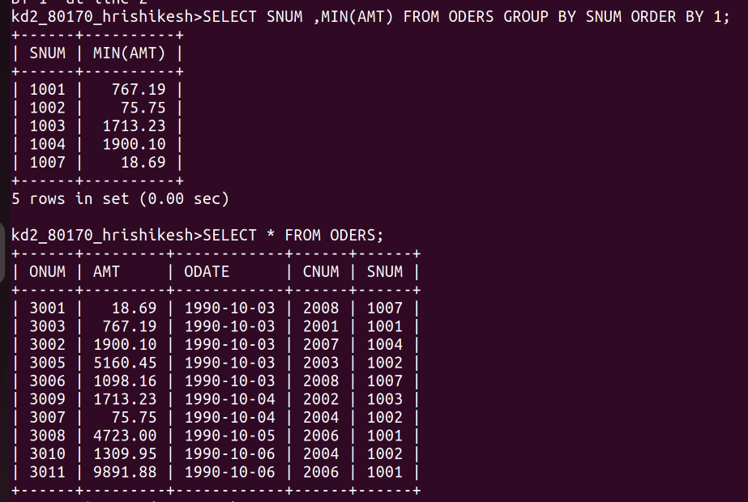

Q4 ANSWER
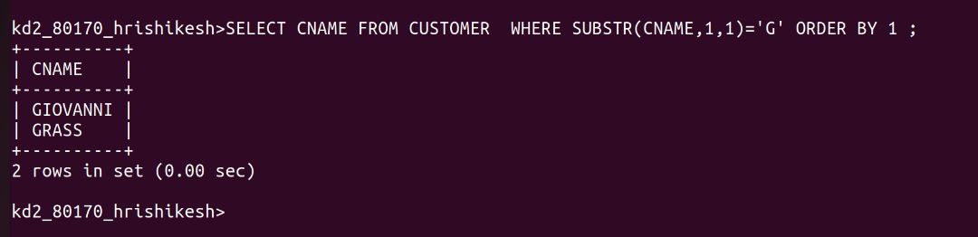

Q NO 5 ANSWER
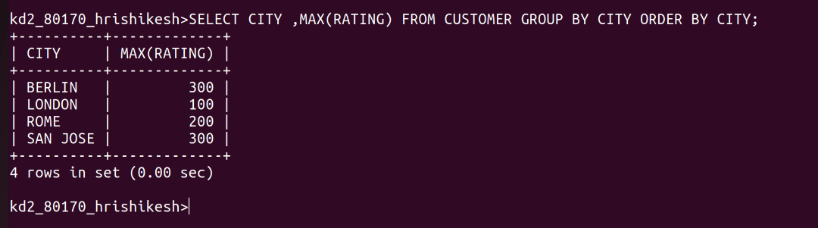

QNO 6 ANSWER

